**MINOR PROJECT**

**ON**

**HOSTEL MANAGEMENT SYSTEM**

**Department of Master in Computer Application**

**2018-2021**

**Guided By:- Submitted By :-**

Asst. Prof **. Name** :Pramod kumar Barik

Ms. Devee Darshani Panda **Regd. no** : T20197191  **Dept. of CSE**

**Contents**

1. Introduction.
2. Aim
3. Objective of project.
4. Software Requirement & Hardware Requirement
5. List of concepts and methods used.

**Introduction :-**

* The project  **HOSTEL MANAGEMENT SYSTEM** Is a project helps to store all student information. like Name , phone no. , father’s name , address .
* All the details related to a hosteller could be find in one place.
* This project main aim to computerization of the hostel management system .
* it is more secure to the manual registration book

**Aim :-**

* Instead of manually storing the hosteller detail , we aim to make an efficient software to do the same.
* It improve efficiency of the system
* It helps to the user

1. Time consuming
2. Secure the data
3. Easy to update information

**Objective :-**

* To the replace existing system which is much more time consuming
* We have add five module these are , view ,insert , delete, update , search
* In this project we are use two technical languages i.e java and SQL.
* Java is use for font end and SQL is use for back end.
* This project enable to the user to store all data in a database ,and it is very easy to fetch/retrieve data from database

**Software Requirement: -**

Operating system : window 10

Java (jdk1.6.0) : for design the project

SQL (oracle 10g ) : for store data

Notepad : for write the source code

**Hardware Requirement:-**

Processor : intel core i3 , 7th gen

RAM : 512MB

ROM : 80GB

**List of concepts and methods used: -**

Here use java(jdk1.6.0) version java application for design our project .and SQL (oracle 10g ) version use for store all information in the database , use notepad for write the source code and also we use DOS for compile and run the project.

Here we have compute 5 module these are VIEW, INSERT , DELETE, UPDATE , SEARCH

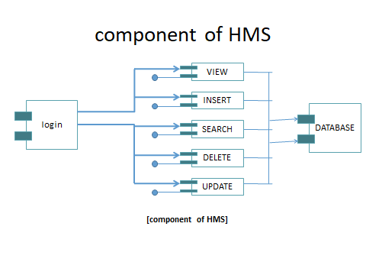

**Login module**

* lt provide authority to entering the system
* Only responsible user use this system because before entering this system it required password then go to the system for uses
* It provide security for data
* Login module connected to data base for check the password or user name .if doesn’t match the password or username if cant be enter the sytem

**Login page source code**

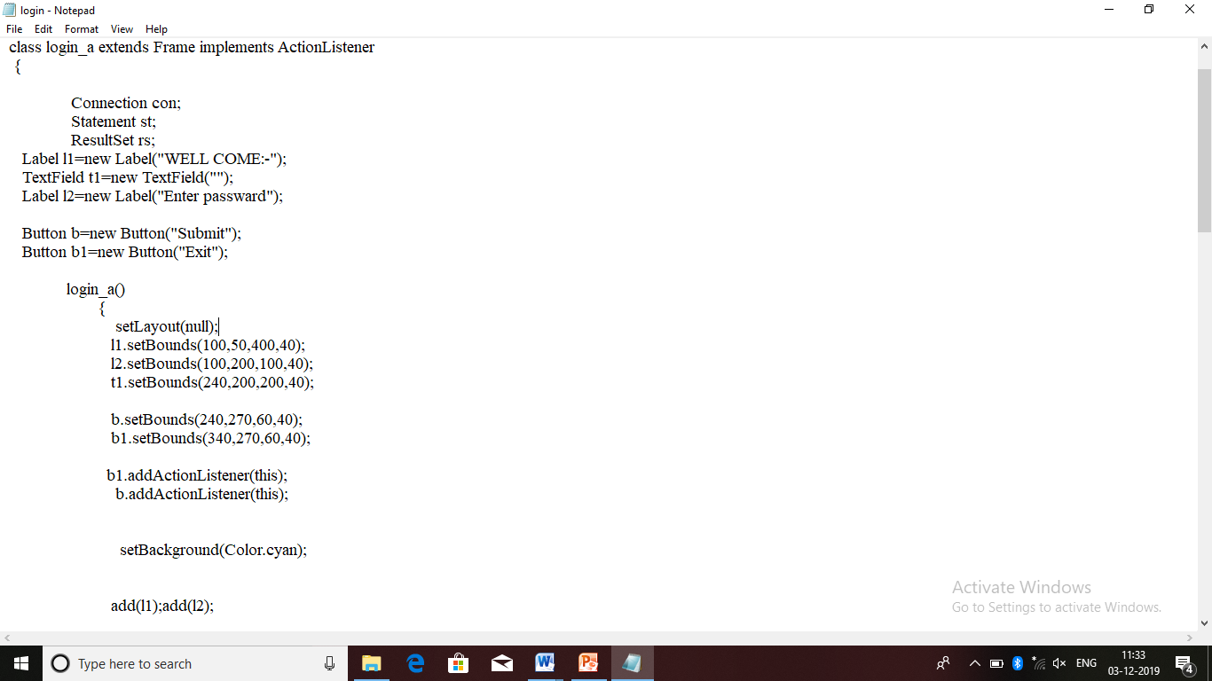

**Output :-**

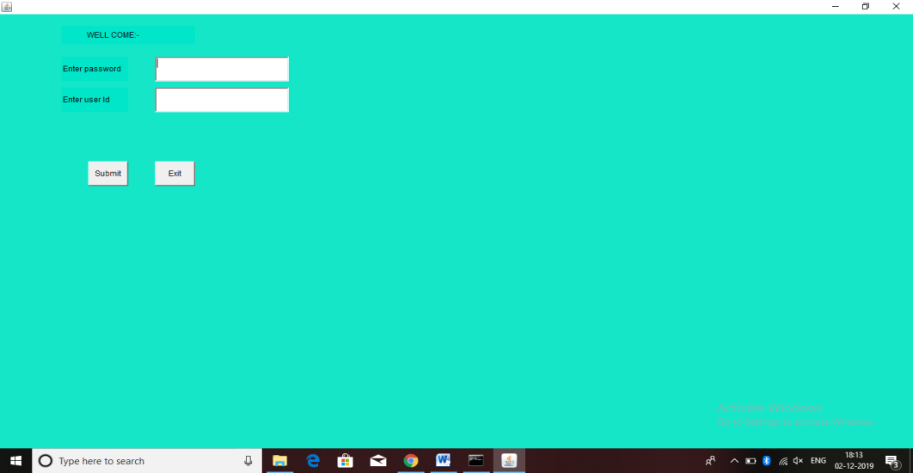

**View module**

* It is retrieve the data from the database shown on the Interface.
* It retrieve the data and with these colum name
* It help us see all data which is stored in the database

**Source code**

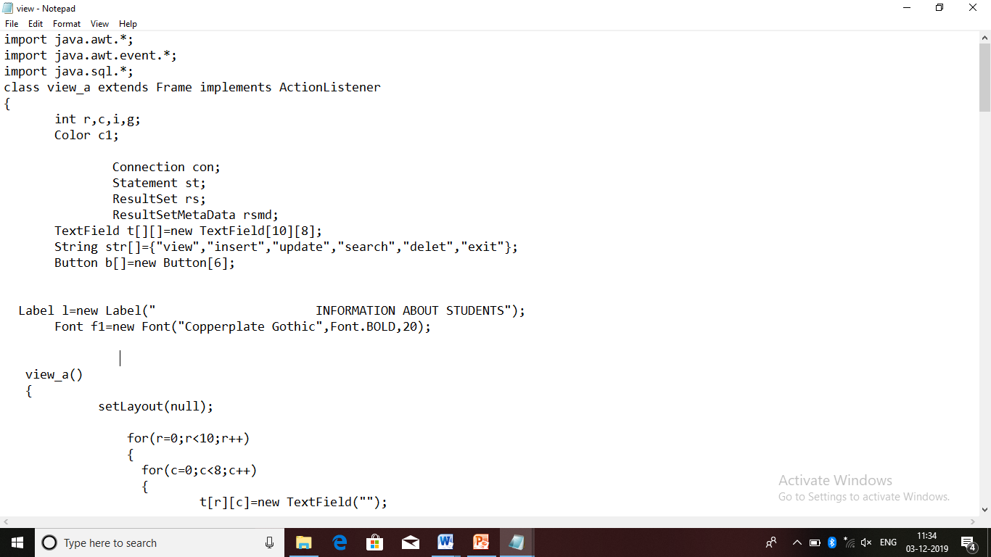

**Output:-**

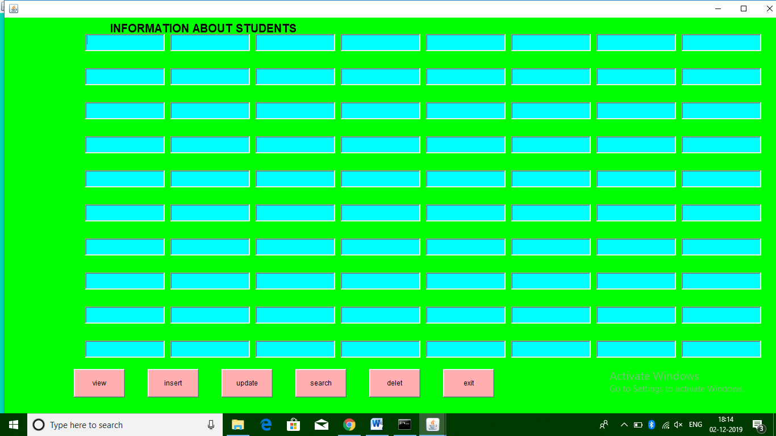

**Insert module**

* Insert module used to stored the data into database
* This module provide easily stored data batter the pen and paper system
* In pen and paper system take much more time to maintain the data but it take less amount of time to maintain the data
* In this module fill all detail about of student then click on submit button then store all data into data base

**Source code :-**

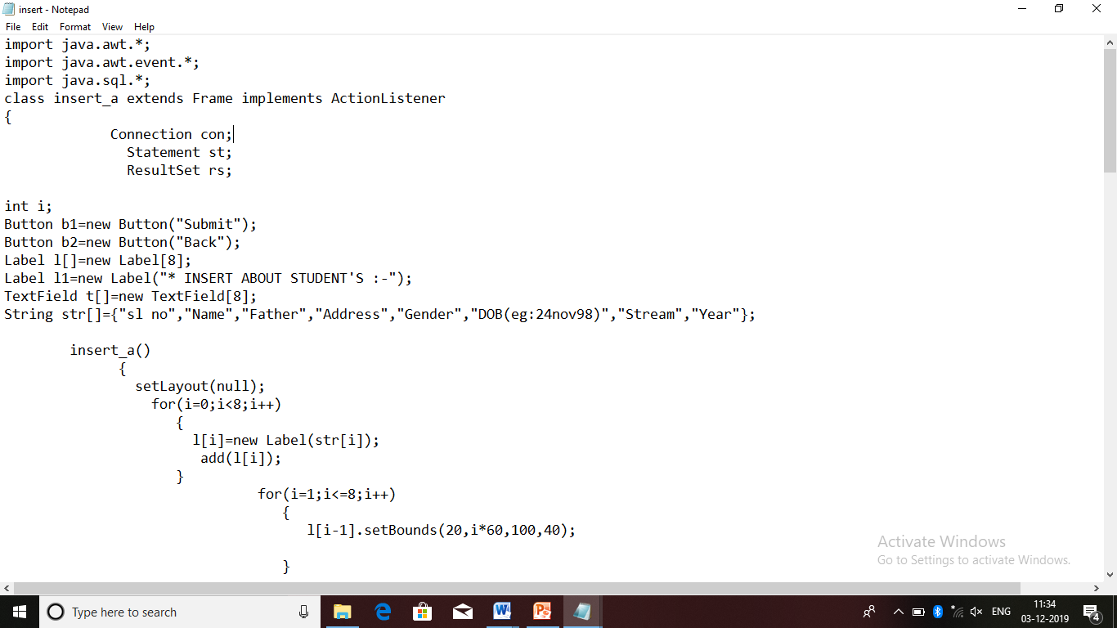

**Output:-**

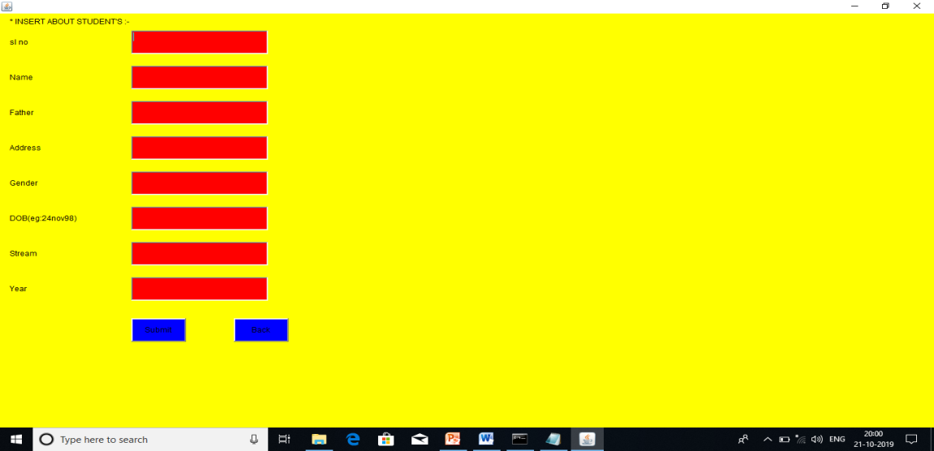

**Update module**

* It is used for re-edit the data ot modify the data ,
* when the user mistakenly insert wrong data so that user can able to rectified or change the data

**source code**

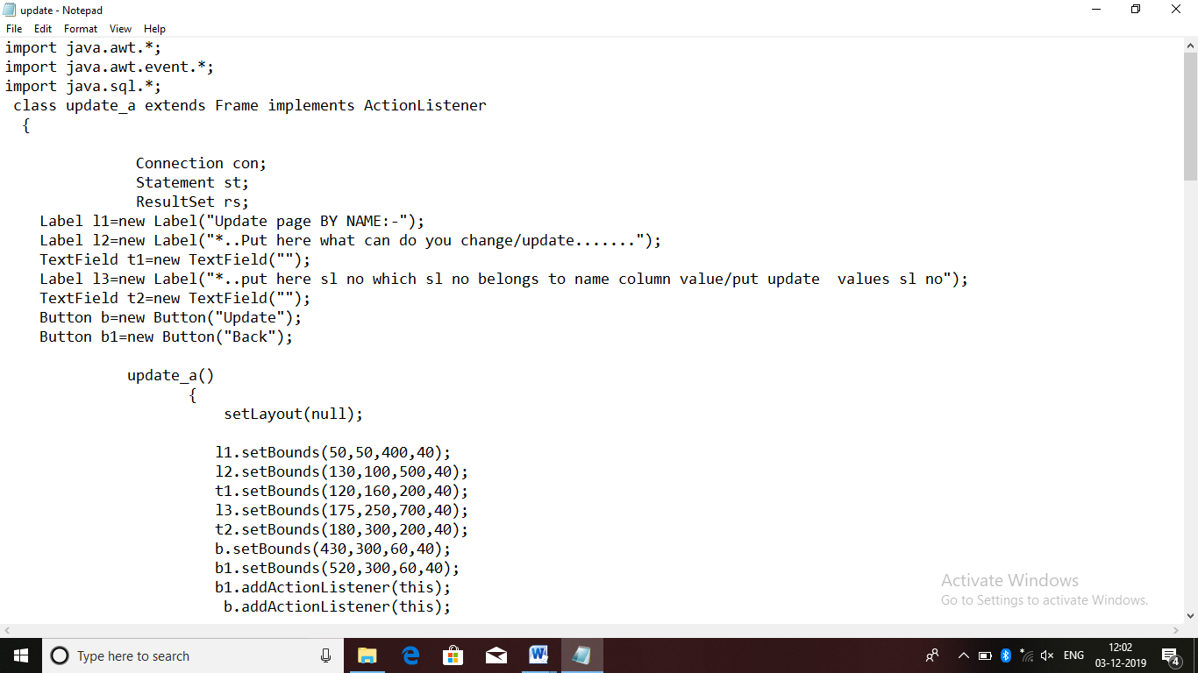

**Output:-**

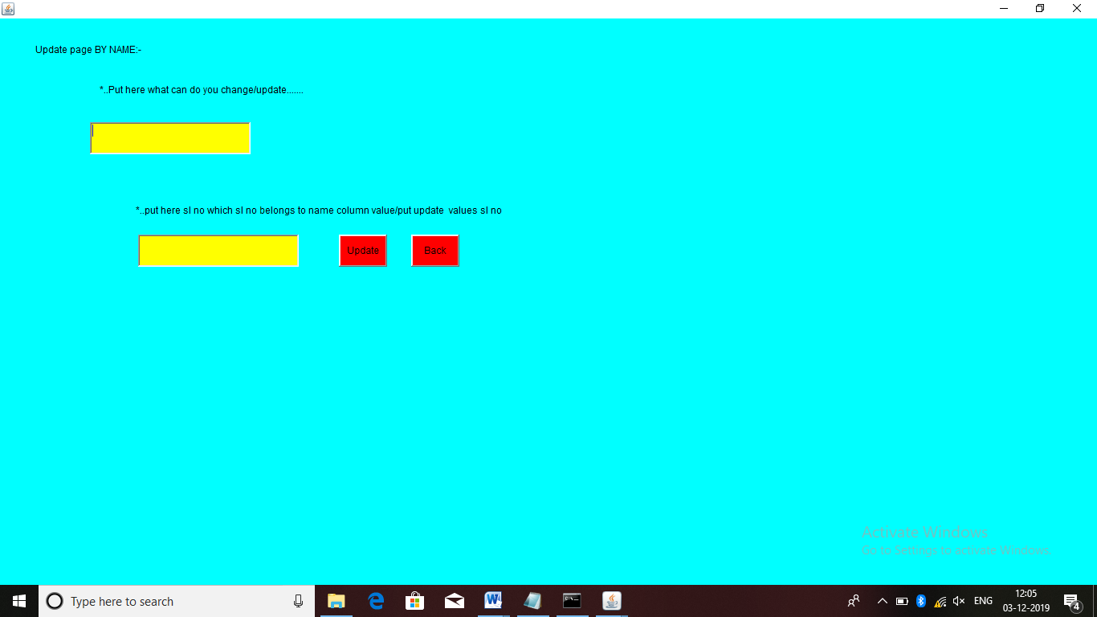**search module**

* In the database store maximum to maximum data these time it can help them. Easily search
* It easily retrieve the data from the database and shown on the interface
* Here search by only name
* It retrieve only one student all detail

**Source code**

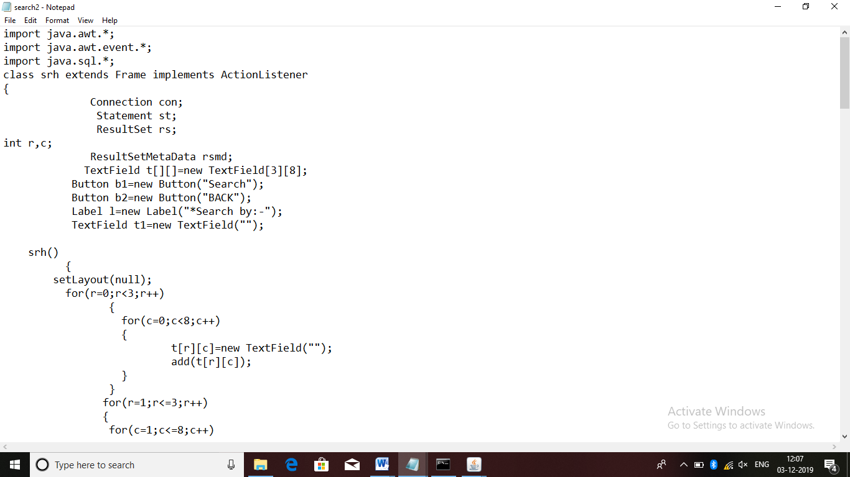

**Out put:-**

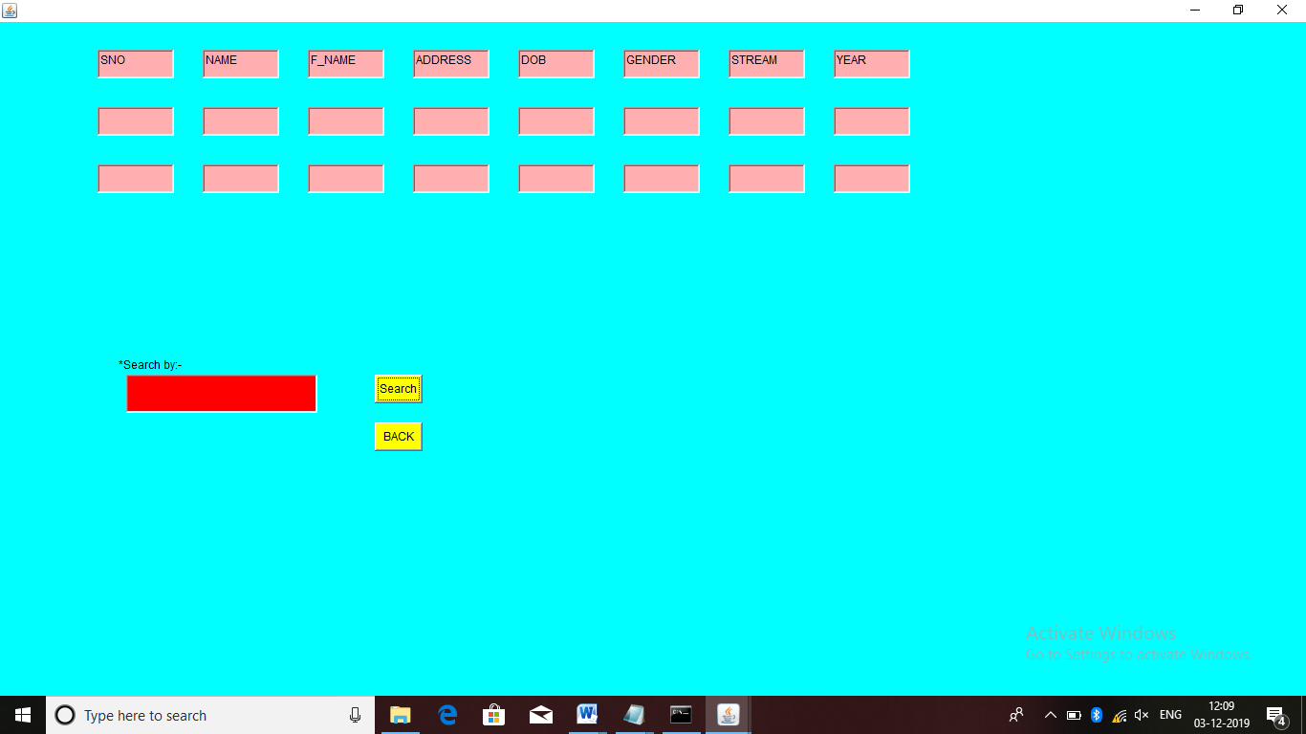

**Delete module**

* In here unnecessary data can be removed through this module
* It is totally remove the data from the database

**Source code**

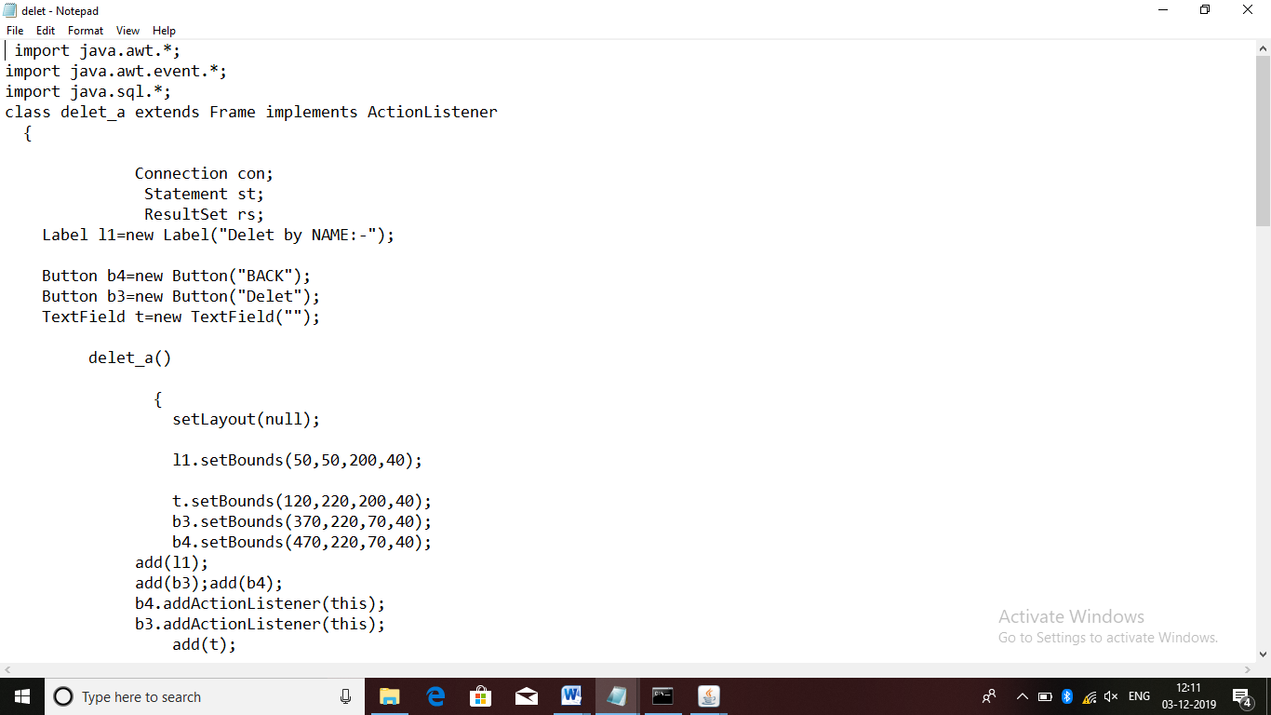

**Output:-**

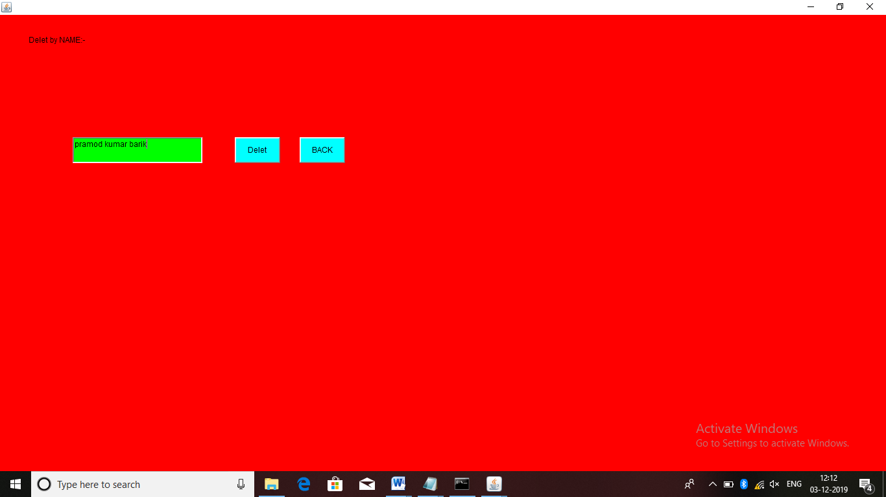

**Reference :-**

**We follows for build this project**

* **Core java 10th  Edition , part II , by Herbert schildt**
* **mySQL (database system) by Narain Gehani**
* [**www.w3schools.com**](http://www.w3schools.com/)
* [**www.mysql.com**](http://www.mysql.com)

**conclusion:-**

* This project offers user to enter the data through simple and interactive manner
* Data storage and retrieval will become faster and easier to maintain

**Student's Name.** **Signature** **Mentor's Signature**

1 . Pramod kumar barik